**Name: sruthy chandran**

**Roll No:43**

**Batch:MCA**

**Date:31/03/22**

**NETWORKING & SYSTEM ADMINISTRATION LAB**

**Experiment No.: 3**

**Aim**

Familiarization of basic linux commands

**Procedure: 1)** pwd

Print working directory.the command prints the complete path of the current working directory

**syntax**: $pwd

**output:**



**2)**mkdir:

Mkdir command in linux /unix allows users to create or make new directory.

**syntax**: $mkdir sruthy

**output:**



3) ls

The ls command is resposible for listing files in a directory.

**syntax**: $ls

**output:** 

4)man pwd

Man command in linux is used to display the user to display the user mannual of any command that we can run on the terminal

**syntax:** $man pwd

**output**:

5)ls -l

The linux command is used to print in the long list format.

**syntax:** $ls -l

**output**:

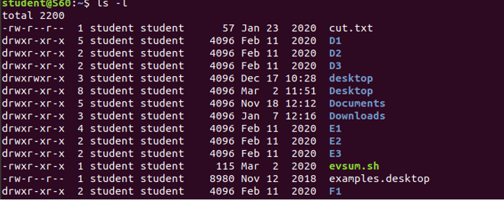

6)ls -h

The command is used for displaying a size of the file human readable format.

**syntax:** $ls -h

**output**: 

7)ls -r

It is usedto print the list in reverse order.

**syntax:** $ls -r

**output**:



8)ls -R

It will display the content of the sub directories.

**syntax:** $ls -R

**output**:

9) ls -a

It will enlist the whole list of the current directory including the hidden files.

**syntax:** $ls -a

**output**:



10) ls -t

It sort the file by modification time showing the last edited file first .to open the last edited file.

**syntax:** $ls -t

**output**: 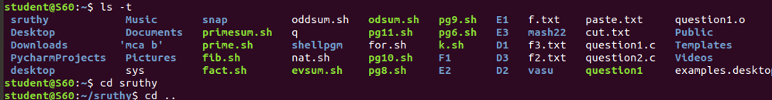

11) cd:

This command in linux is known as change directory command. It is used to change working directory.

**syntax:** $cd sruthy

**output**:

12) cat

Cat is the short for concaternate this command display the content of one or more file without having to open the file for editing.

**syntax:** cat>a.txt

**output**:

13)cat>>a.txt

Use(>>)operater to apped the content using the cat command followed by a directory operator(>)and name of the fle you want to create.

**syntax: $**cat>>a.txt

**output**:

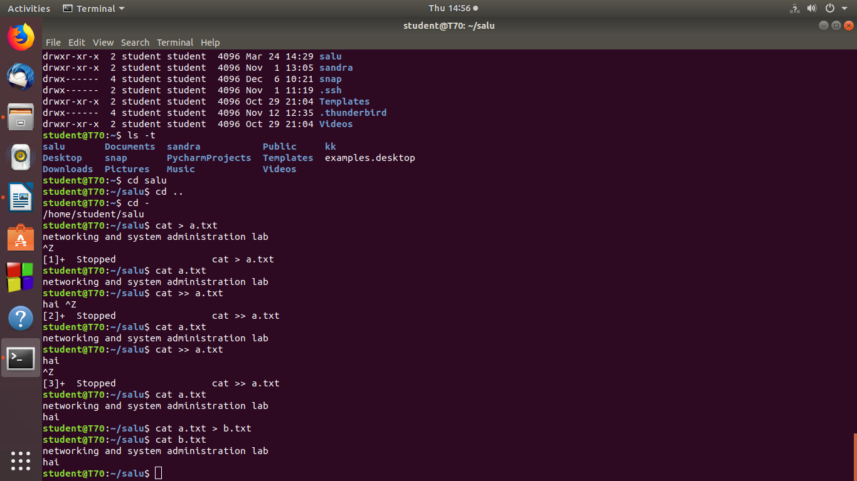

14)cat a.txt>b.txt

Copy the content of the a. txt to b.txt using(>)operator

**syntax: $**cat a.txt>b.txt

**output**:

